Talha Khan
IT-481-DL1
3/16/2026

Assignment: Lab 7 – Encrypting data using AWS KMS

Step 1: I logged into the AWS Management Console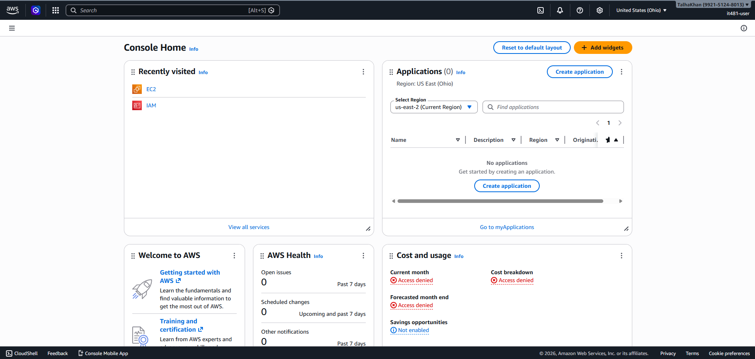
Step 2: In the search bar at the top, I typed “KMS” and clicked on “Key Management Service”. 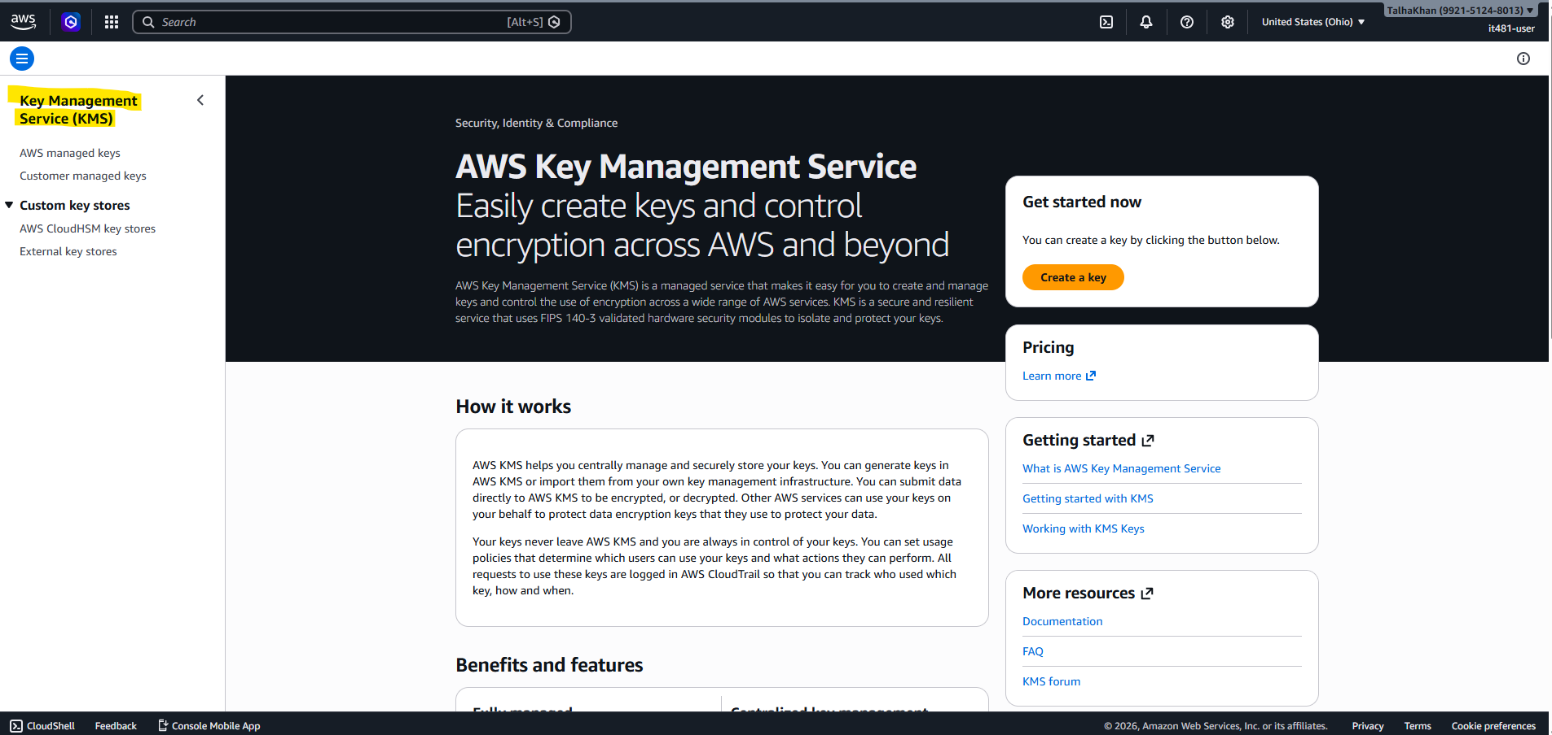
Step 3: Next, I clicked on “Customer Managed Keys” and then “create key”:
- Key Type: Symmetric
- Key usage: Encrypt and decrypt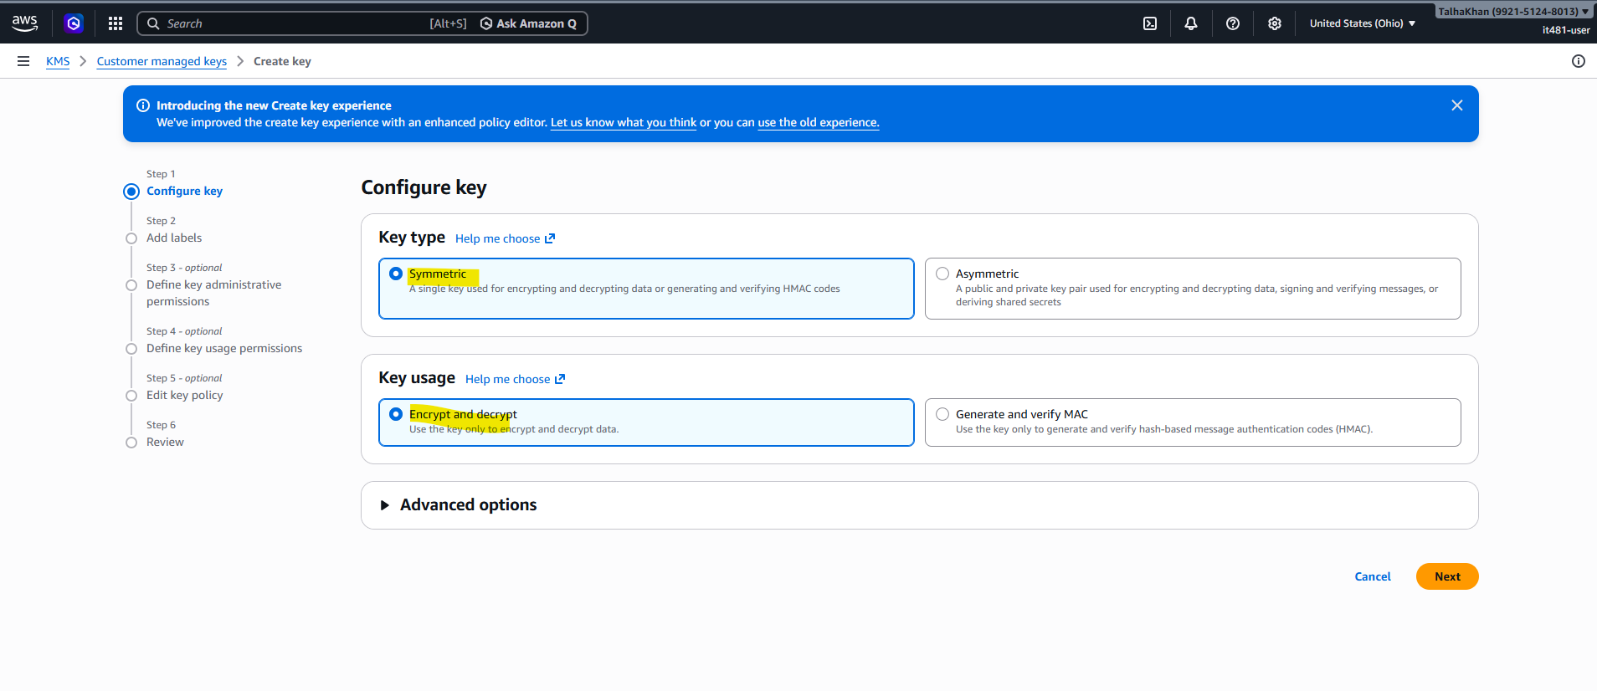
- Alias: it481-lab7-kms-key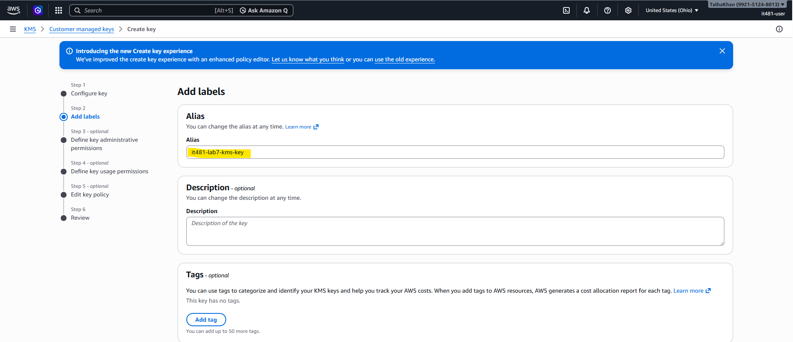
- Key Administrators: selected my IAM user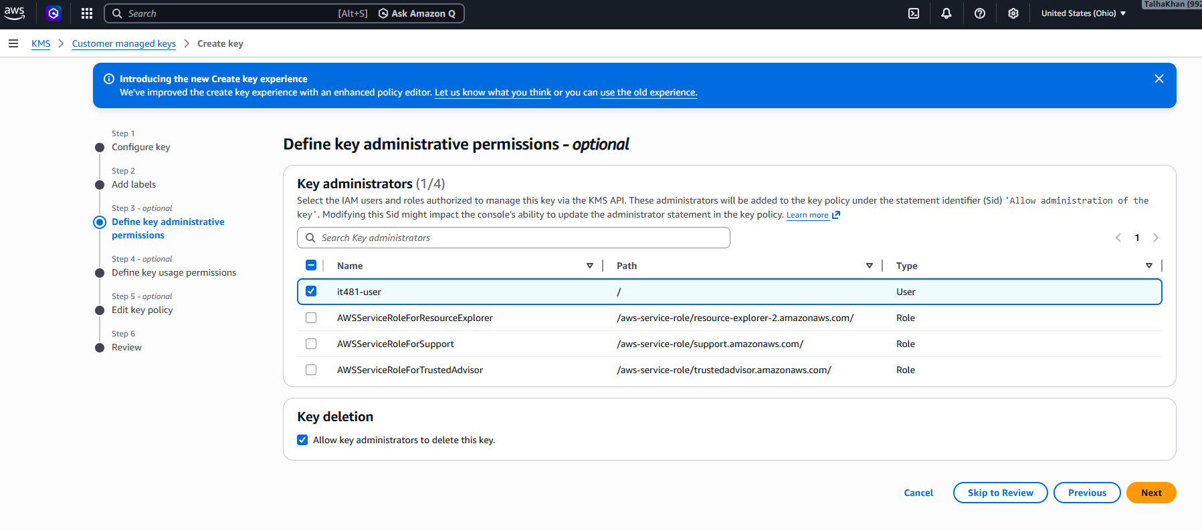
- Key Users: Selected my IAM user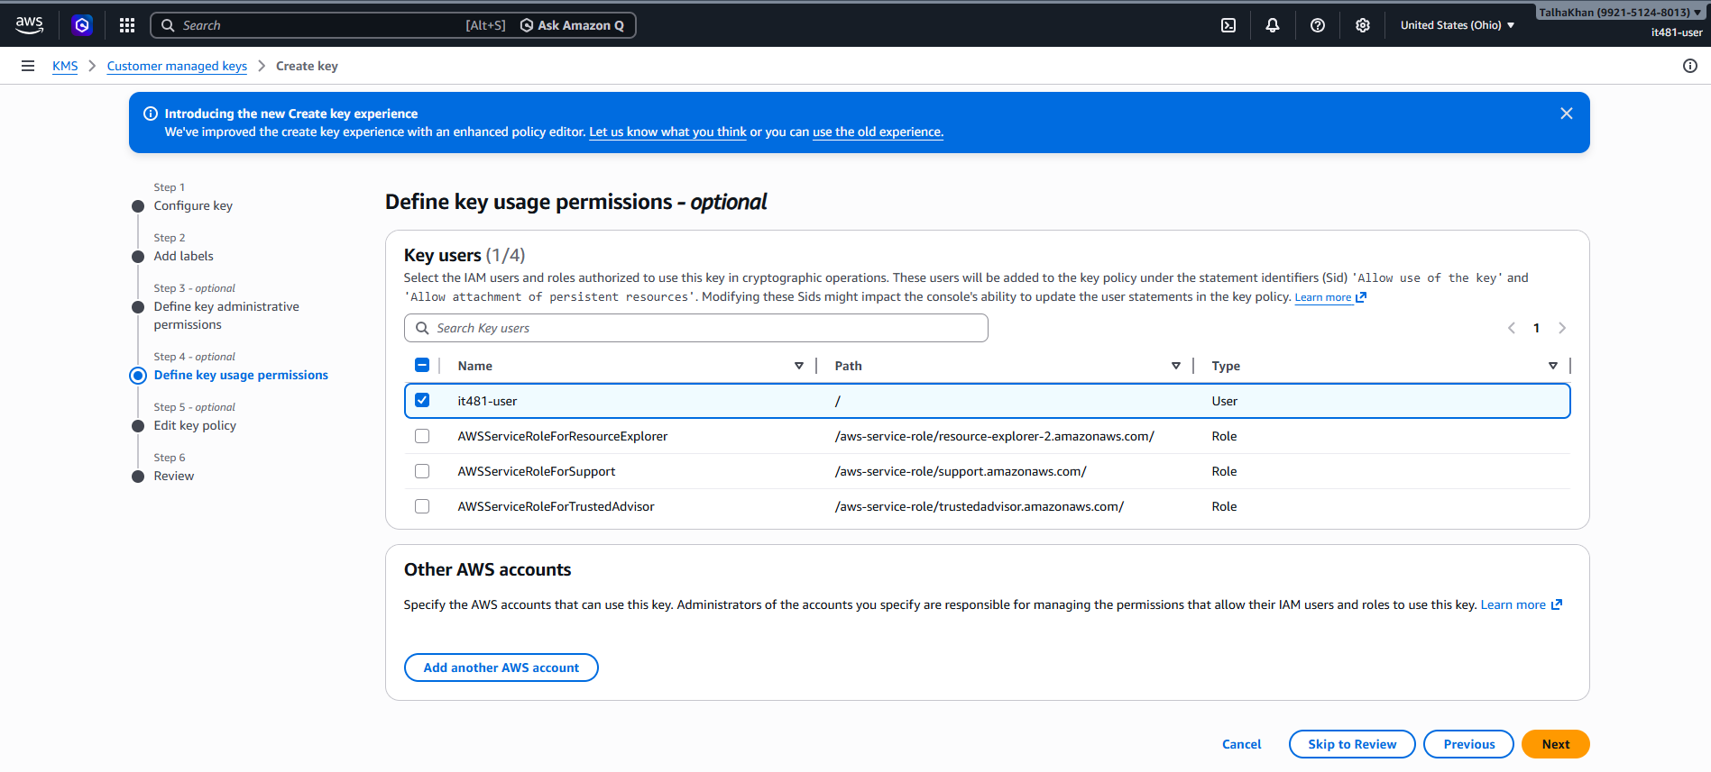
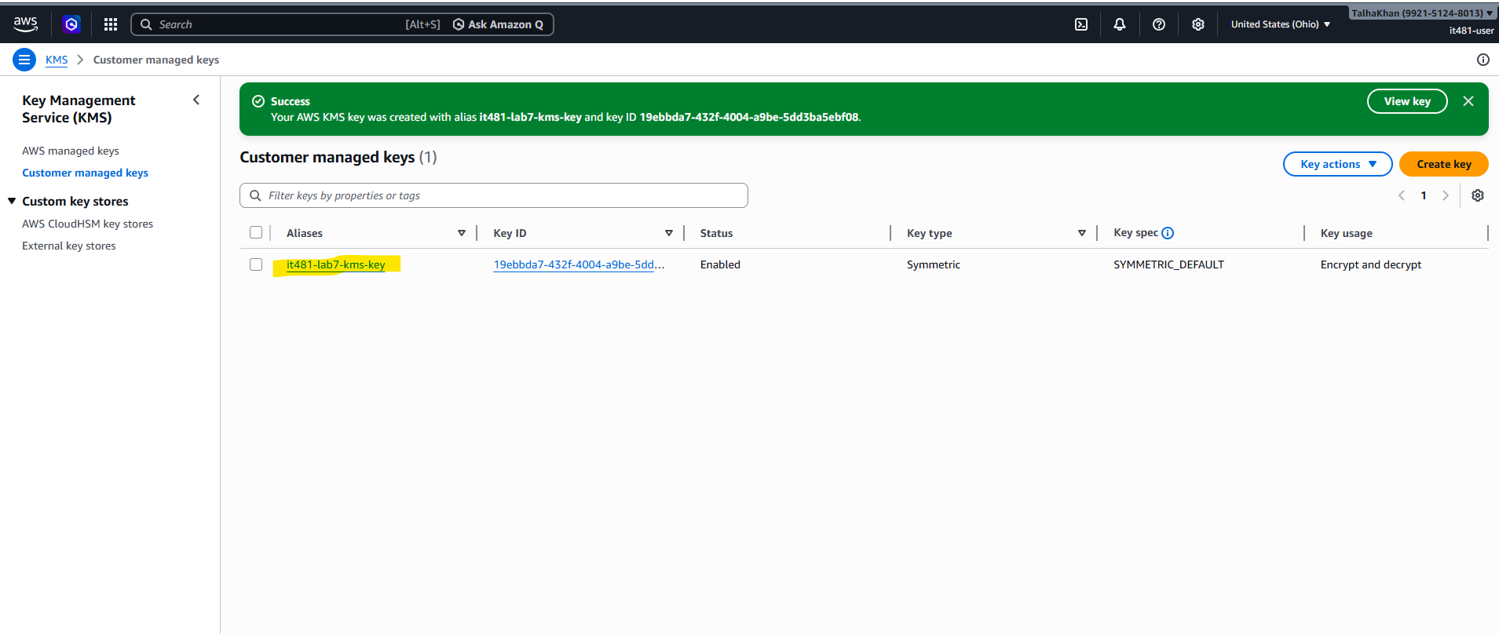

Step 4: Once finished, I search for S3 in the search bar and clicked on “Create Bucket”:
- Name: it481-lab7-kms-321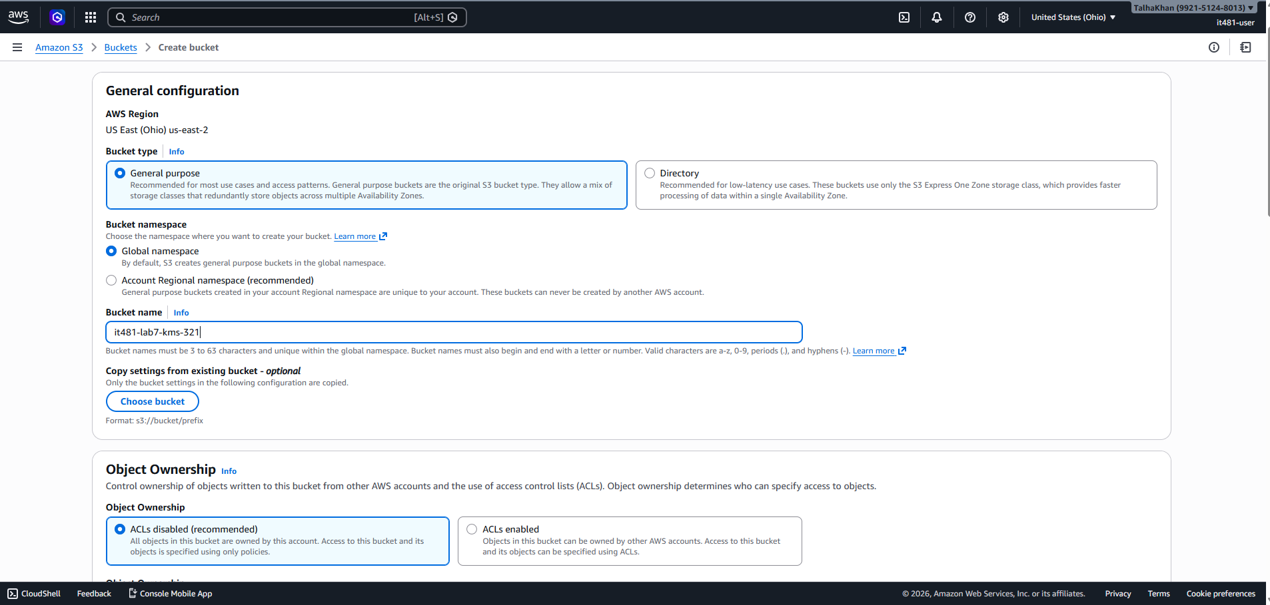
- In the “Default Encryption section, I selected the SSE KMS option. Then, I selected “choose from your AWS KMS keys and picked the CMK I just created. 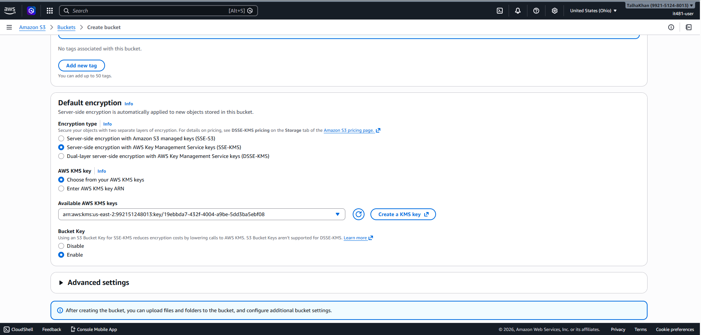
- Created the Bucket: 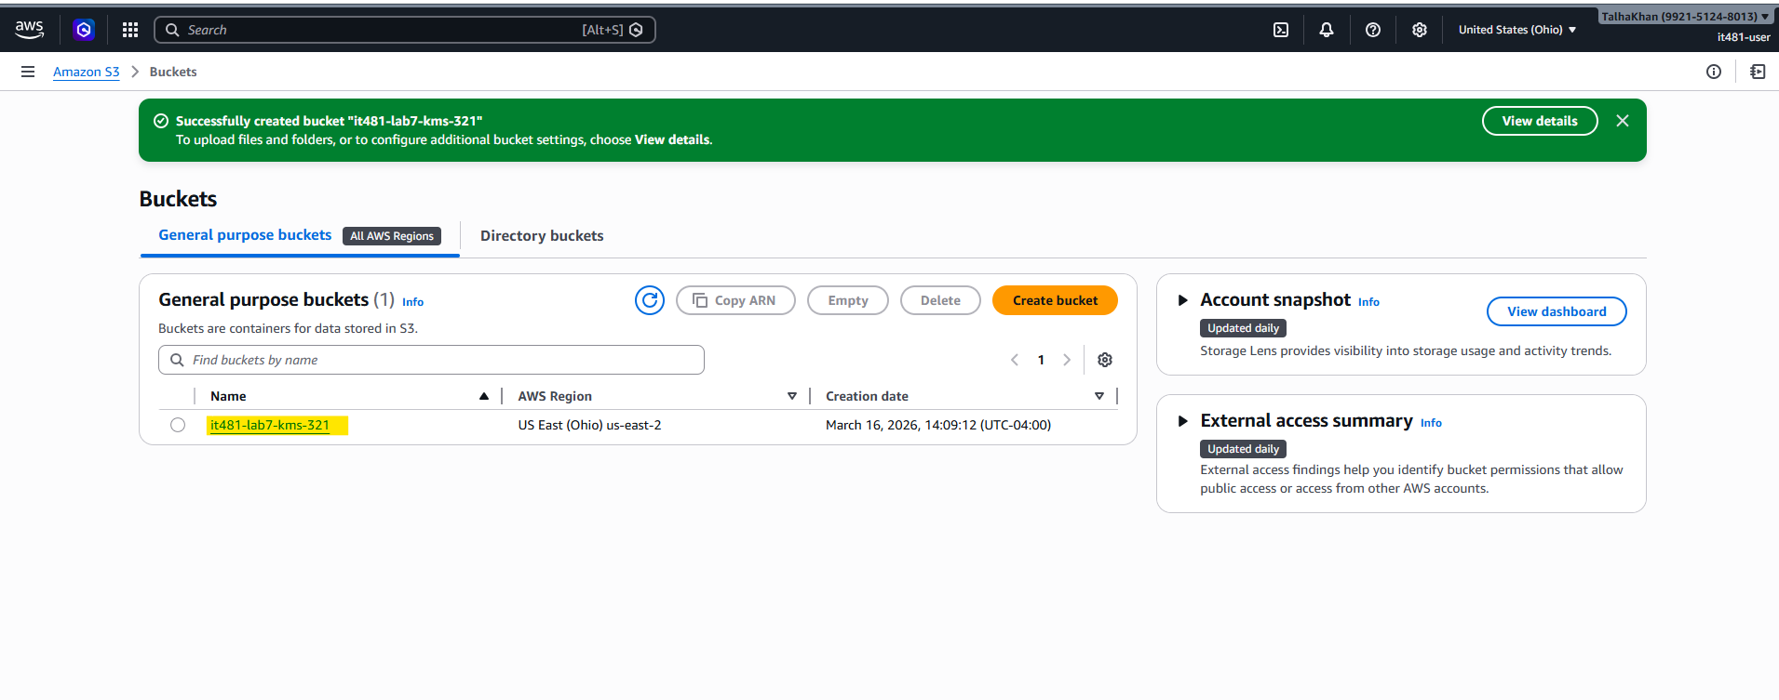

Step 5: I opened the bucket I just created and clicked on “Upload” and “Add files”. I chose any small file. 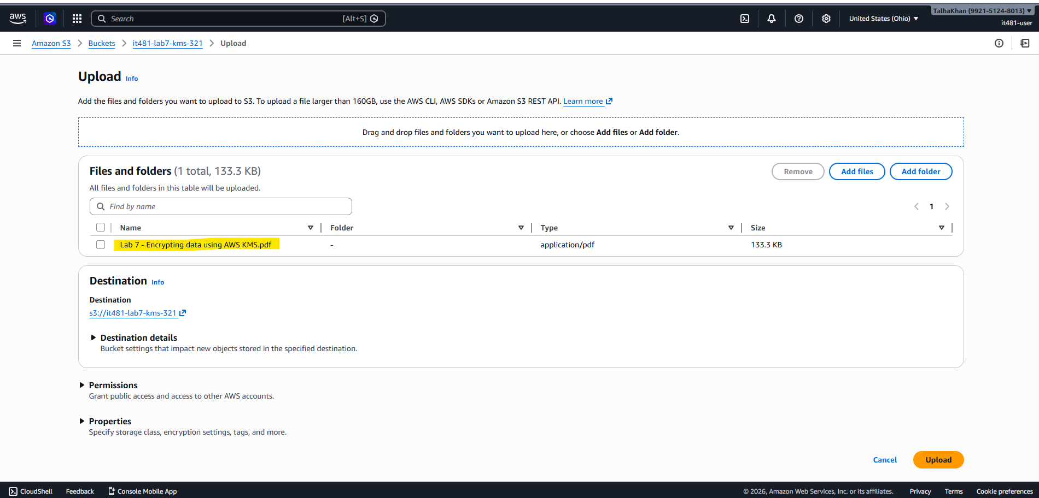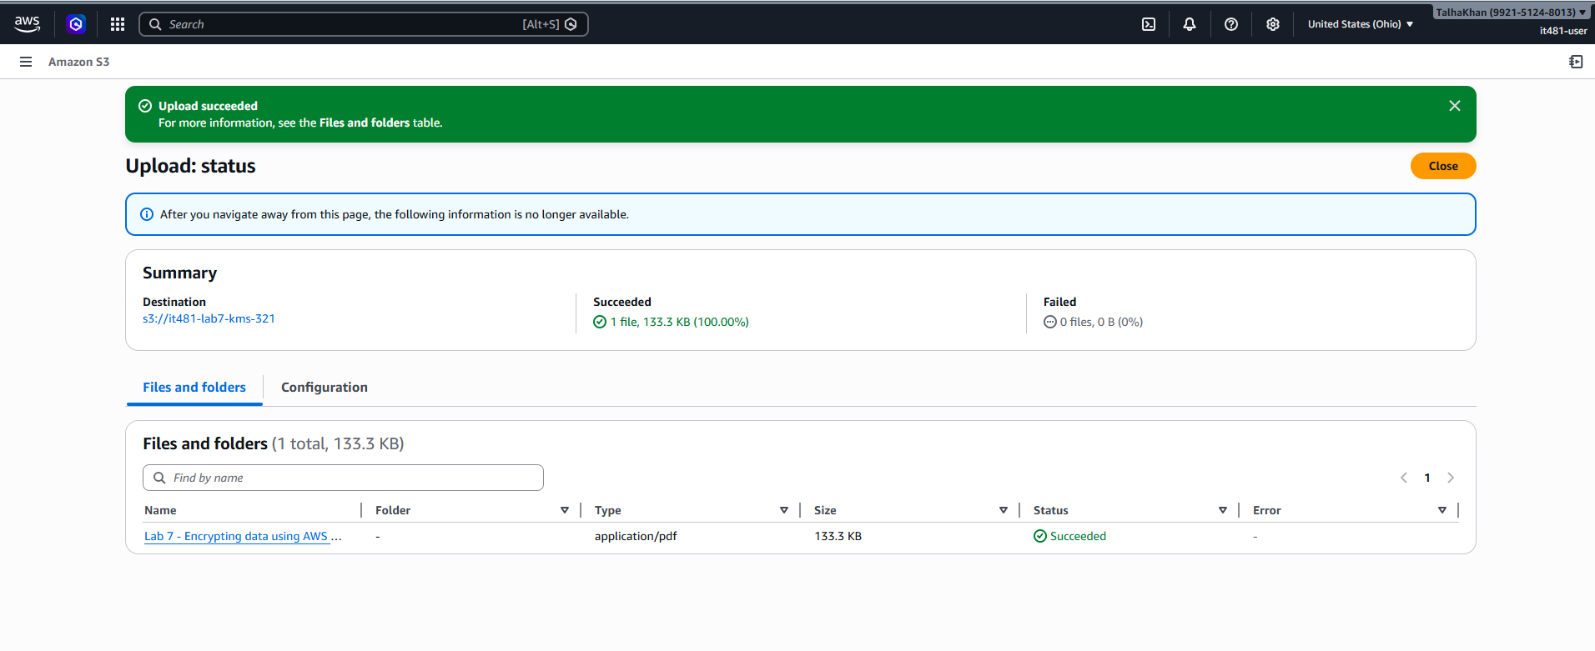

Step 6: I clicked on the uploaded object in the bucket and scrolled to “Server-side encryption” settings. Then, I verified that the encryption type is AWS KMS and the KMS key is the CMK I created earlier. 